Project Design Phase-II
Technology Stack (Architecture & Stack)
Date | 03 October 2026
Team ID | SWTID-2026-3878
Project Name | Implement Client Script & UI Policy (Incident)
Maximum Marks | 4 Marks
Project Overview:
This project implements Client Scripts and UI Policies on the ServiceNow Incident form to improve user experience, enforce field behaviour and reduce incorrect data entry. Form fields are controlled dynamically based on user actions and incident conditions, without needing to submit the form. A UI Policy on the Incident table makes selected fields mandatory, read-only or visible when its condition is met, so users supply the required information and follow consistent data-entry practices when creating or updating incidents.
Team Details:
S.No | Name | Role
1 | Ashwini V | Team Leader
2 | Gunasri E | Team Member
3 | Dhivyabharathi G | Team Member
4 | Asanciya V | Team Member
5 | Niveatha J | Team Member
Technical Architecture:
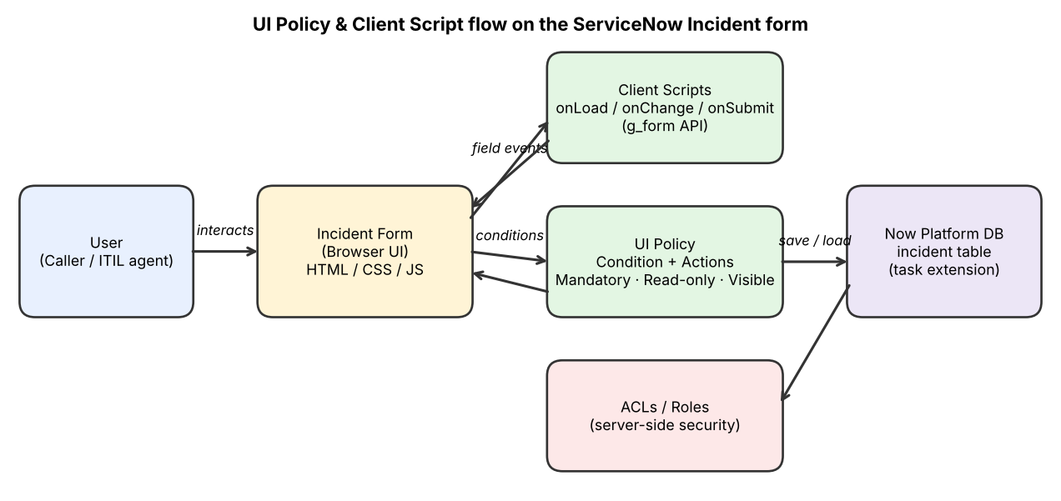
Table-1 : Components & Technologies:
S.No | Component | Description | Technology
1 | User Interface | Incident form in the ServiceNow platform UI where callers and agents enter and update incident records; fields change dynamically as the user works, without submitting the form. | ServiceNow Platform UI (HTML, CSS, JavaScript), Form Layout / Form Designer
2 | Application Logic-1 | UI Policy on the Incident table: when a defined condition is met, selected fields are made mandatory, read-only or visible/hidden. | ServiceNow UI Policy (Conditions + UI Policy Actions)
3 | Application Logic-2 | Client Scripts (onLoad / onChange / onSubmit) for behaviour a UI Policy cannot cover, e.g. field messages and validation before save. | JavaScript, g_form / g_user client APIs
4 | Application Logic-3 | Immediate user feedback on the form: info, error and field messages that guide correct data entry. | g_form.showFieldMsg, addInfoMessage, addErrorMessage
5 | Database | Incident records (extends the Task table); fields such as Caller, Category, State, Priority, Short description and Resolution notes drive the policy conditions. | ServiceNow relational database (incident table)
6 | Cloud Database | Database hosted and managed by the ServiceNow cloud instance; no separate database setup needed. | ServiceNow Now Platform (cloud-hosted)
7 | File Storage | Attachments added to incidents are stored by the platform. | ServiceNow attachment storage (sys_attachment)
8 | External API-1 | Not used. All form behaviour runs inside the ServiceNow instance. | Not applicable
9 | External API-2 | Not used. | Not applicable
10 | Machine Learning Model | Not used in this project. | Not applicable
11 | Infrastructure (Server / Cloud) | Application deployed on a ServiceNow instance in the cloud. Cloud configuration: ServiceNow Personal Developer Instance (PDI). Local server: none required, only a web browser. | ServiceNow Cloud instance
Table-2: Application Characteristics:
S.No | Characteristics | Description | Technology
1 | Open-Source Frameworks | Not a core part of the solution: the logic is written in standard JavaScript on the ServiceNow platform; no external open-source framework is required. | JavaScript (ECMAScript)
2 | Security Implementations | Access to the Incident form and fields is controlled by user roles and ACLs. UI Policies and Client Scripts only improve the form experience, so server-side ACLs remain the real access control. Access is over HTTPS. | Role-based access control, ACLs, HTTPS/TLS
3 | Scalable Architecture | Multi-tier platform (browser, application, database). Form logic runs in each user's browser, so it adds little server load as users grow. | ServiceNow multi-tier architecture
4 | Availability | Availability is provided by the ServiceNow cloud platform (managed, redundant infrastructure). | ServiceNow cloud hosting
5 | Performance | UI Policies are declarative and preferred over scripts where possible; Client Scripts avoid heavy server calls so the form stays responsive; rules run instantly on field change without a form reload. | UI Policy, lightweight Client Scripts
References:
https://c4model.com/
https://www.ibm.com/cloud/architecture
https://aws.amazon.com/architecture
https://developer.servicenow.com/

